Dataset

What is a Dataset?
# Source: AI Source: Provided by: [Data Path: Persons Table -> ID Column: 1, Name_En Column: Motasem Essam] -> From: [Chatgpt (GPT‑5 Mini)] on [12/10/2025]
A dataset is a collection of related data organized in a structured format so it can be easily stored, processed, and analyzed.
Datasets are commonly used in databases, data analysis, statistics, and machine learning.

Basic Idea
# Source: AI Source: Provided by: [Data Path: Persons Table -> ID Column: 1, Name_En Column: Motasem Essam] -> From: [Chatgpt (GPT‑5 Mini)] on [12/10/2025]
A dataset usually contains:
- Rows (records or observations) → individual entries
- Columns (attributes or variables) → types of information about each entry

Example Dataset
# Source: AI Source: Provided by: [Data Path: Persons Table -> ID Column: 1, Name_En Column: Motasem Essam] -> From: [Chatgpt (GPT‑5 Mini)] on [12/10/2025]
Student dataset:
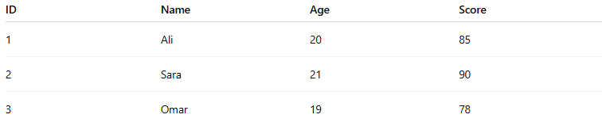
ID | Name | Age | Score
1 | Ali | 20 | 85
2 | Sara | 21 | 90
3 | Omar | 19 | 78
Here:
- Rows represent students.
- Columns represent attributes (ID, Name, Age, Score).

Types of Datasets

1. Structured Dataset
# Source: AI Source: Provided by: [Data Path: Persons Table -> ID Column: 1, Name_En Column: Motasem Essam] -> From: [Chatgpt (GPT‑5 Mini)] on [12/10/2025]
Data organized in tables with rows and columns.
Examples:
- SQL databases
- Excel spreadsheets
Example:
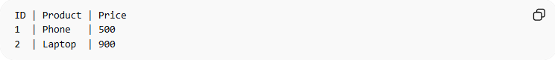
ID | Product | Price
1 | Phone | 500
2 | Laptop | 900

2. Semi-Structured Dataset
# Source: AI Source: Provided by: [Data Path: Persons Table -> ID Column: 1, Name_En Column: Motasem Essam] -> From: [Chatgpt (GPT‑5 Mini)] on [12/10/2025]
Data that has some organization but not strict tables.
Examples:
- JSON
- XML
Example (JSON):
{
"Name": "Ali",
"Age": 20,
"Score": 85
}

3. Unstructured Dataset
# Source: AI Source: Provided by: [Data Path: Persons Table -> ID Column: 1, Name_En Column: Motasem Essam] -> From: [Chatgpt (GPT‑5 Mini)] on [12/10/2025]
Data that has no predefined structure.
Examples:
- Images
- Videos
- Emails
- Audio files
- Text documents

Where Datasets Are Used
# Source: AI Source: Provided by: [Data Path: Persons Table -> ID Column: 1, Name_En Column: Motasem Essam] -> From: [Chatgpt (GPT‑5 Mini)] on [12/10/2025]
Datasets are used in many fields:
- Data analysis
- Machine learning
- Business intelligence
- Scientific research
- Data warehouses
Example:
A company may use a dataset containing millions of customer transactions to analyze buying patterns.

Simple Summary
# Source: AI Source: Provided by: [Data Path: Persons Table -> ID Column: 1, Name_En Column: Motasem Essam] -> From: [Chatgpt (GPT‑5 Mini)] on [12/10/2025]
A dataset is:
- A collection of related data
- Organized for storage, processing, and analysis
- Often arranged in rows and columns
Example:
Dataset = Table of data
Rows = records
Columns = attributes

